# Create a Milestone Action Template Procedure

Service Level Management

**Purpose**

Milestone Actions are used in conjunction with Milestones to define the notification process when a Monthly SLA is in danger of being breached or has been breached. SLM uses Action templates for multiple Service Targets to ensure that notifications are consistent regardless of the Service or Service Level Tier.

***Note:*** *For customized Milestones, see the* [Create a New Service Target for a Platinum Application](https://confluence.jacksonnational.com/display/CPENABLE/Create+a+New+Service+Target+for+Platinum+Application) procedure*.*

**Related Policy**

* [IT Service Management Policy](https://sharepoint.jackson.com/sites/itsmsd/servicelevelmanagement/Shared%20Documents/Pre%20December%202019/SLM%20Documents/Policy%2C%20Process%2C%20Procedures/SLM_Service%20Level%20Management%20Process.doc?d=wa1eaba53e1dc4b30abda2a0886981cc9)

**Audience**

The following groups are responsible for adhering to this document:

* Service Level Management

**Procedure**

|  |  |
| --- | --- |
| Step | Action |
| 1 | Identify the compliance target percentage that is required for the Milestone Action template:   1. Review the Metric Data Definition (MDD) spreadsheet (see ***Appendix A***) to identify each application’s compliance target (the required percentage to meet the SLA). |
| 2 | Access the Templates section of Remedy to verify if a viable template already exists:   1. In the Remedy system, select the Applications tab on the side. 2. Select “Administrator Console”. 3. Select “Application Administration Console”.   cid:image001.png@01D32CA3.A8FED240   1. Click the “Custom Configuration” tab.      1. Click “Service Level Management” drop down-arrow. 2. Click “Configure Application Settings” drop down-arrow.      1. Click “Templates” from list.      1. This will bring up the “Configure Templates” screen. In the “Show Templates For” field, select “Action” from the drop-down list.      1. A list of Milestone Action templates will appear.   See ***Appendix B*** for standard naming convention.     1. Click “Name” on the blue bar to put the templates in alphabetical order.      1. If the Milestone Action template you are looking for exists, you are done with this procedure. 2. If the desired template does not exist, continue to Step 3. |
| 3 | **To Create a New Milestone Action Template:**   1. Click the “Create button.      1. In the “Used By” field, select “CI-Outage” from the drop-down menu. 2. In the “Action Type” field, select “Alert or Email”.   ***Note:*** *At this time “Alert or Email” are the only actions being performed.*    ***Note:*** *The “Applies To” field will auto populate*.   1. Click the “OK” button. 2. For this example, an action is being created to send an email alert when a 99% Service Target is at 90% in danger of being breached. Fill in the following fields:  * **Title:** Enter a name to best describe what the Milestone Action is.   See ***Appendix B*** for the standard naming convention.   * **Description:** Copy and paste the “Title” name into this field. * **Delivery Method:** Select “Email” from the drop-down list. * **To:** Type in the group name in which the email is to be sent.   **Subject:** Type in what the subject line of the email should be.  See ***Appendix C*** for an example.   * **Message:** Type in what the body of the email should be.   See ***Appendix C*** for an example.     1. Click the “OK” Button.   ***Note:*** *Milestone Action templates will be linked to Milestone templates during the creation of a Service Target.*  For more information see:  [Create a Milestone Template Procedure](https://confluence.jacksonnational.com/display/CPENABLE/Create+a+Milestone+Template)  [Create a New Service Target for a Platinum Application](https://confluence.jacksonnational.com/pages/viewpage.action?spaceKey=CPENABLE&title=Create+a+New+Service+Target+for+Platinum+Application) |

**Appendix A – Metric Data Definition Forms / Compliance Target**

Locate the correct [Metric Data Definition (MDD](https://sharepoint.jackson.com/sites/itsmsd/servicelevelmanagement/_layouts/15/start.aspx#/Shared%20Documents/Forms/AllItems.aspx?RootFolder=%2Fsites%2Fitsmsd%2Fservicelevelmanagement%2FShared%20Documents%2FPre%20December%202019%2FMDD%20Database%20Files&FolderCTID=0x012000C3EC5FEE7B19F646BACB9A57478C774E&View=%7B527EAB19%2D8D4A%2D47E6%2DACE1%2DCA631A3D99D0%7D)) spreadsheet in SharePoint.

***Note:*** *At this time only Service Targets for Platinum applications would have Milestones Templates applied to them, therefore the Metric Database CPI data spreadsheet should be used*.

1. Access the correct spreadsheet in which the application falls under.

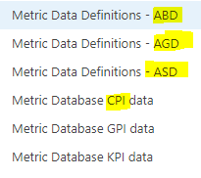

* + **ABD** – Aggregate Bronze Definitions
  + **AGD** – Aggregate Gold Definitions
  + **ASD** – Aggregate Silver Defintions
  + **Metric Database CPI Data** – Platinum definitions

1. Locate the application in the spreadsheet.
2. Review “Column F” (Compliance Minimum) on the specified application’s row.

In this example, 99.0100% is the minimum percentage in which the SLA can be met.

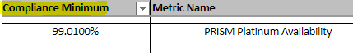

**Appendix B: Milestone Action Standard Naming Convention**

The Milestone Action template is named in the “Title” field.

Below are naming examples for percentage milestones and a breached milestone.

* + **Percentage Milestone**

Notify SLM Managers_AT XX% EA YY

* EA = Expected Availability
* XX = milestone percentage
* YY = compliance target percentage

Example:

Notify SLM Managers_AT 90% EA 99%

* + **Breached Milestone**

Notify SLM Managers_AT Breached EA YY%

* YY = compliance target percentage

Example:

Notify SLM Managers_AT Breached EA 99%

**Appendix C: Milestone Action Examples**

The following is an example of a Milestone Action template that has been created for a 99% compliance target that is at the 50% mark of being in danger of being breached for the month. Do not update any of the variables (see Variable Key) used in the subject line or the body of the email.

**Variable Key:**

* + **$ApplicationUserFriendlyID$** = The name of the service.
  + **$PGDS_SLM_CrossReferenceID$** = The Incident number
  + **$Assignment Status$** = The current status of the ticket
  + **$Assigned Group$** = The group that the ticket is currently assigned to
  + **$Assignee$** = The individual who is assigned the ticket. Will be blank if ownership has not been taken.

***50% Milestone of 99% Compliance Target***

**Title:** Notify SLM Managers_AT 50% EA99%

**Subject:**

SLA Availability for $ApplicationUserFriendlyID$ is at 99.5% for Incident Ticket $PGDS_SLM_CrossReferenceID$

**Message:**

The SLA goals are in jeopardy for $ApplicationUserFriendlyID$. Please reference Incident ticket $PGDS_SLM_CrossReferenceID$ to help resolve this issue. $ApplicationUserFriendlyID$ has an expected availability of 99% and it is at 99.5%.

Status: $Assignment Status$

Assigned Group: $Assigned Group$

Assignee: $Assignee$

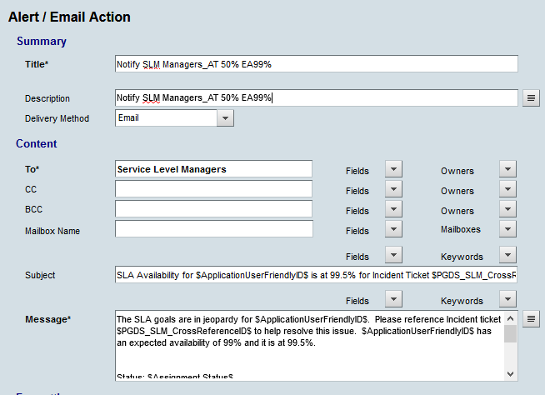

The following is an example of a Milestone Action template that has been created for a 99% compliance target that has been breached for the month. Do not update any of the variables (see Variable Key) used in the subject line or the body of the email.

***Breached 99% Compliance Target.***

**Title:** Notify SLM Managers_AT Breached EA99%

**Subject:**

SLA Availability for $ApplicationUserFriendlyID$ is at 98.99% for Incident Ticket $PGDS_SLM_CrossReferenceID$ and has

**Message:**

The SLA goals have breached for $ApplicationUserFriendlyID$. Please reference Incident ticket $PGDS_SLM_CrossReferenceID$ to help resolve this issue. $ApplicationUserFriendlyID$ has an expected availability of 99% and has fallen below that goal.

Status: $Assignment Status$

Assigned Group: $Assigned Group$

Assignee: $Assignee$

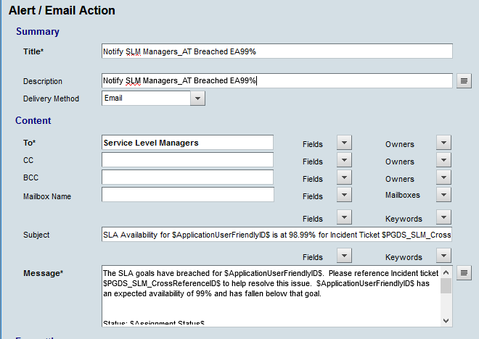

**Appendix D: Milestone Action & Associated Service Targets**

When a Milestone Action template is linked to a Milestone template within a Service Target, the associated Service Targets will appear in the bottom box on the “Configure Templates” screen. Click on the Milestone Action template in the top box to display the list of associated Service Targets.

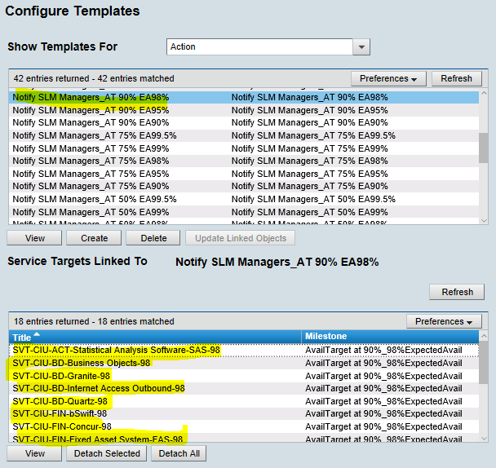

**Modification**

The following associates can make modifications to this document:

* Manager, Service Level Management
* Director, IT Service Management
* Vice President, Service Delivery
* Chief Technology Officer, PGDS

|  |  |
| --- | --- |
| Service Level Management Process | |
| Responsible Party: Piepkow, Manager, Service Level Management Approving Authority: Rob Kolm, Director, IT Service Management | Date Created: 08/08/2017 Last Modified: 05/13/2020 Last Reviewed: |